Lab No. 04

Encapsulation in C++

Lab Objectives | Following are the lab objectives:  - Understand the concept of encapsulation in Object-Oriented Programming.  - Learn how to declare private data members in a class.  - Implement setters and getters to control access to private data.  - Apply encapsulation to create secure and modular C++ programs.

Student ID | 10011 | Student Name |  | Sajjal Tariq
 | Marks |  | Obtained Marks |  | Comments
Task 1 | 15
Task 2 | 15
Task 3 | 15
Total Marks | 45
 | Lab Instructor

Encapsulation in C++
Encapsulation means combining data and the functions that work on that data into a single unit, like a class. In Object-Oriented Programming, it helps keep things organized and secure.
For example, think of a company with different departments—finance, sales, and accounts. Each department handles its own tasks and data. The finance department deals only with financial records, and the sales department handles only sales. Just like that, in programming, each class manages its own data and operations, keeping everything separate and protected. That's encapsulation.
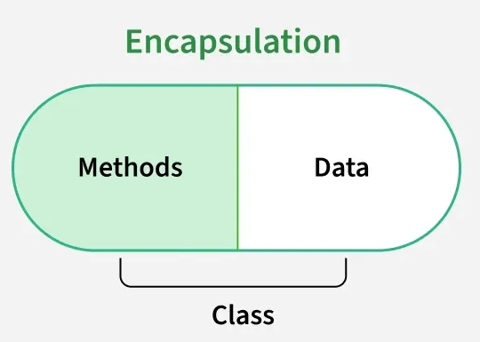

Encapsulation is implemented using classes and access specifiers that keeps the data, and the manipulating methods enclosed inside a single unit. The direct advantage of this packaging is that only the required components are visible to the user, and other information is hidden.
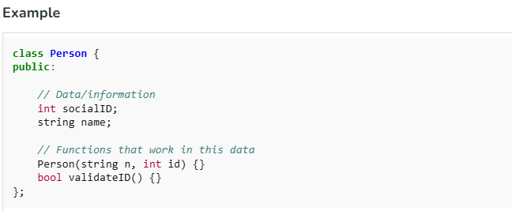
In the above, encapsulation is demonstrated through the Person class, which encapsulates both data and the methods that represents the details of a real-world person.
Encapsulation facilitates data hiding in C++ by using private, protected and public access specifiers for restricting access to the class member functions and data members. For example, the above class Person can be rewritten as:
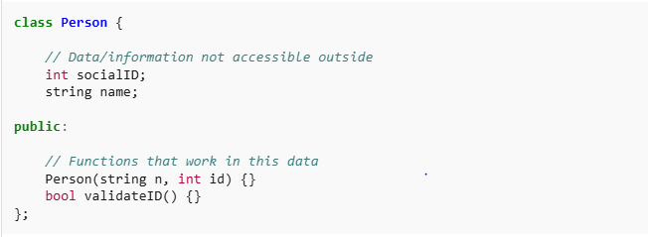
The class has two private data members: socialID and name. The private access specifier ensures that the socialID and name cannot be accessed directly from outside the class, enforcing data hiding. But there may be cases where you need to access or modify the private members such as name. This can be done by using getter and setter methods:
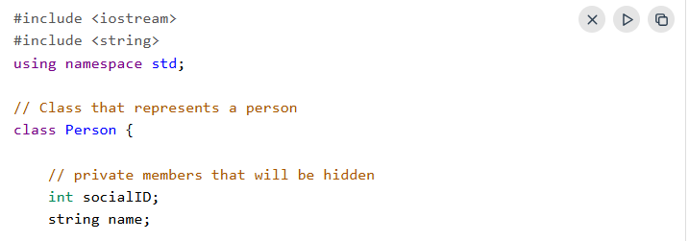
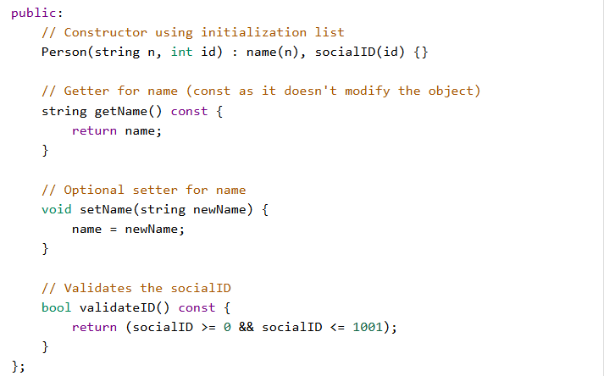
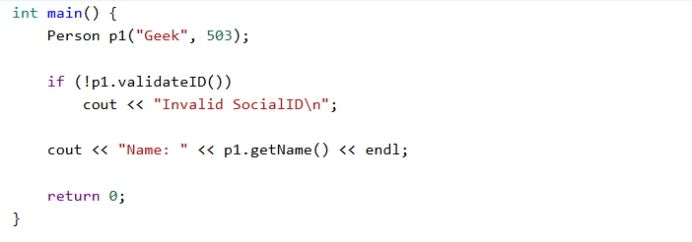

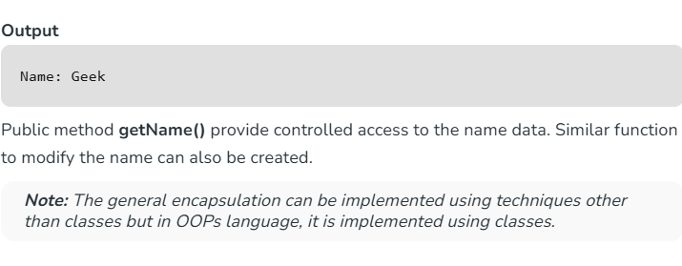

Lab Tasks
Task 1 (15 marks) Create a class Person with private data members name and socialID.
- Write setter and getter functions to update and display the values.
- Demonstrate data hiding by trying to access private members directly (should give an error).
CODE:
- 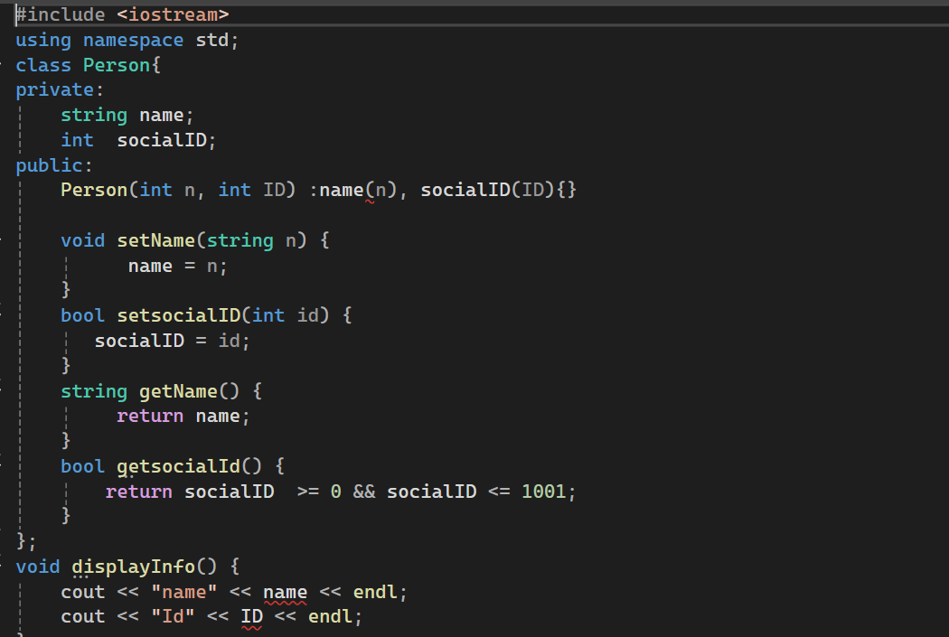
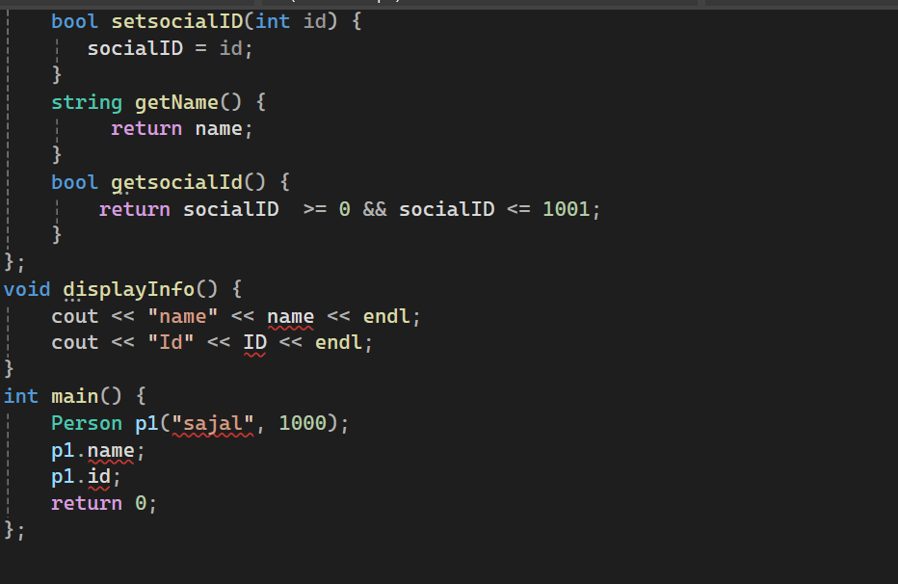
Task 2
Create a class called MotorVehicle that represents a motor vehicle using data members: make (type string), fuelType (type string), yearOfManufacture (type int), color (type string), and engineCapacity (type int). Your class should have three constructors (default, argument & copy) that initialize all data members. Provide setter and getter methods for each data member. Add a member function called displayCardDetails( ) that displays the five data members in five separate lines in the form “member name: member value”.
Write a program to demonstrate MotorVehicle’s capabilities

Code:
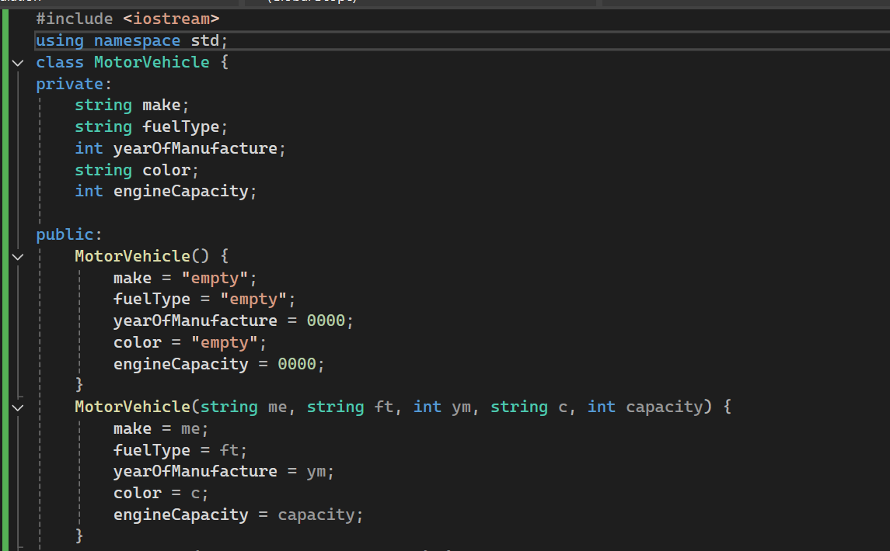
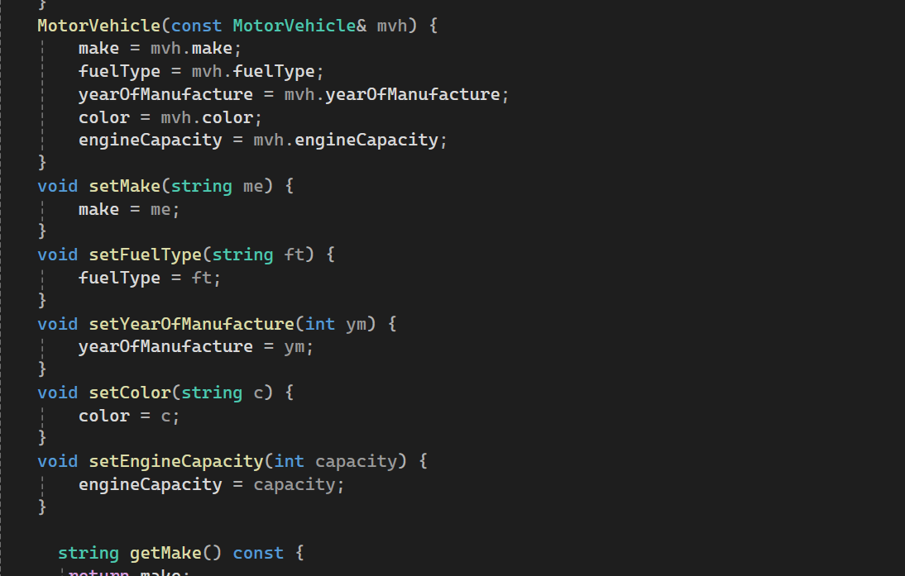
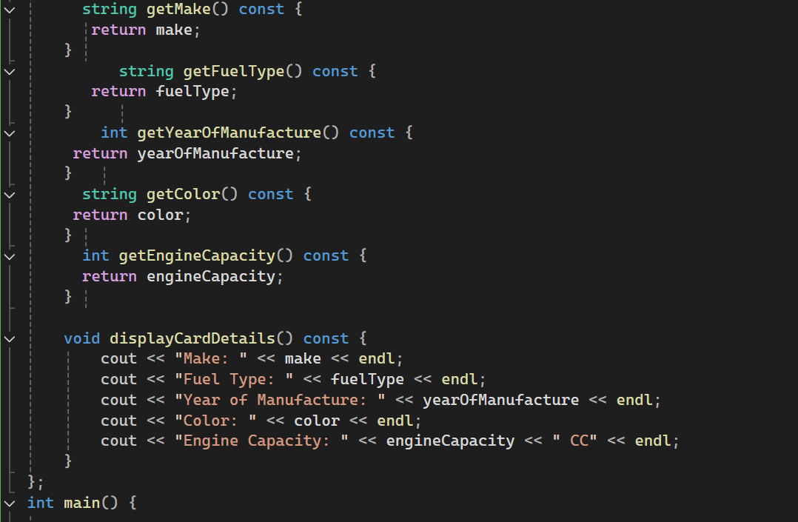
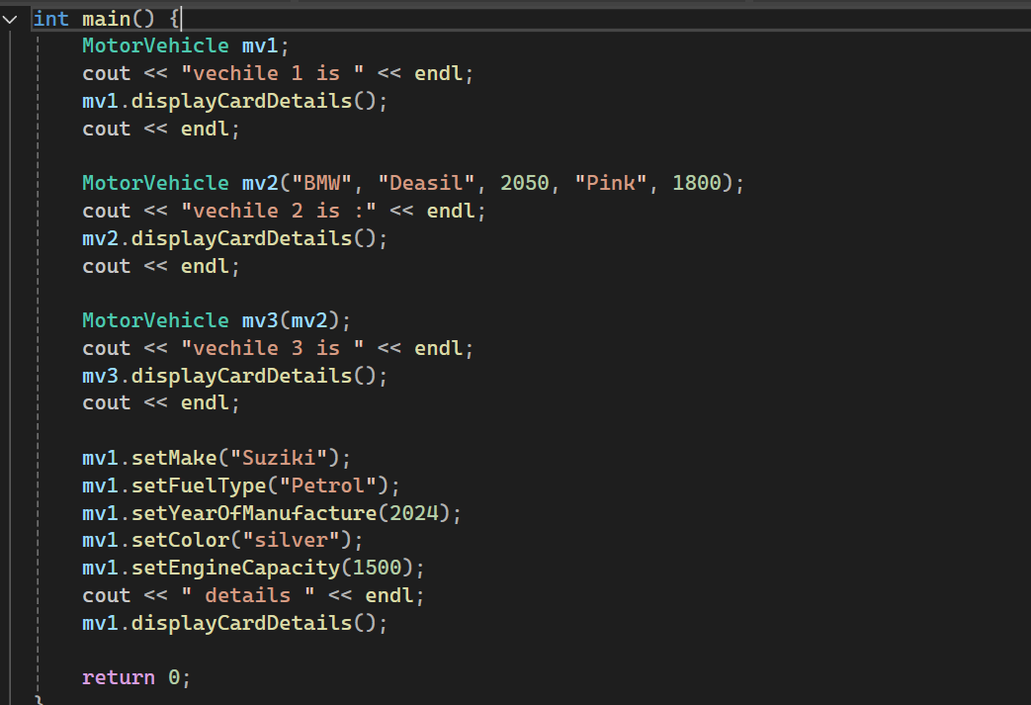

Output:

Task 3
Create a class called Date that includes three pieces of information as data members; a month (type int), a day (type int), and a year (type int). Your class should have three constructors that initialize the three data members. For the purpose of this exercise, assume that the values provided for the year and day are correct, but ensure that the month value in the range 1-12; if it isn’t, set the month to 1.
Provide setter and getter methods for each data member. Provide a member function displayDate() that displays the month, day and year in the provided format, i.e. day – month – year.
Write a test program that demonstrates class Date’s capabilities.

CODE:
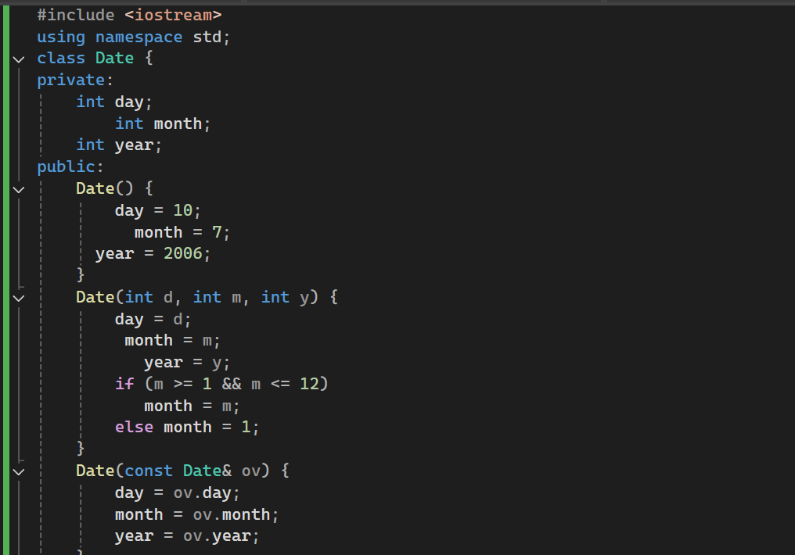
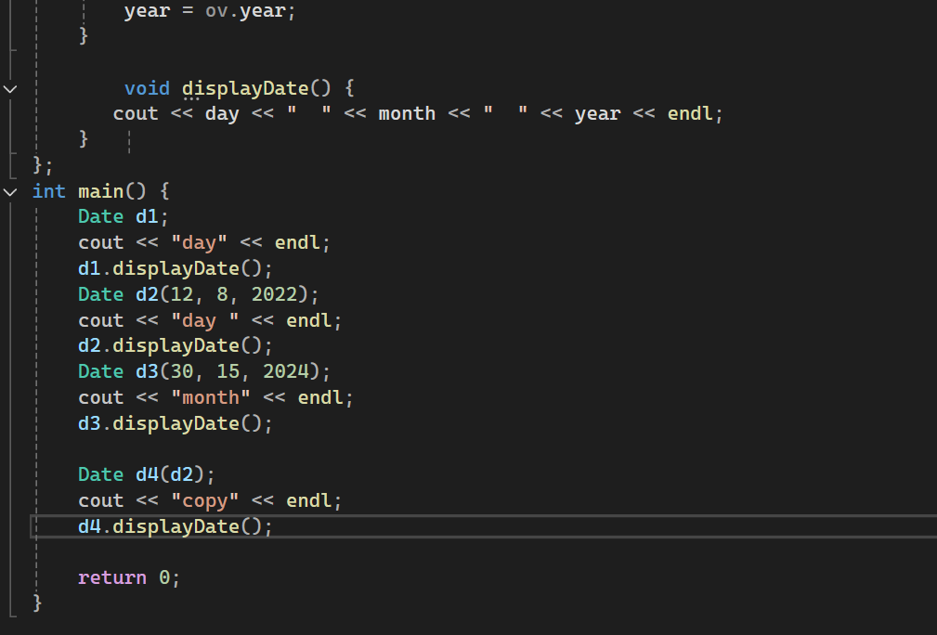
OUTPUT:


